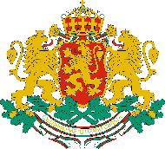 | CONSULATE GENERAL OF THE REPUBLIC OF BULGARIA  IN NEW YORK

NEWSLETTER – JANUARY 2024
You are welcome to the following events in and around New York, co-organized by the Bulgarian Consulate General in New Yorк and/or including representatives of the Bulgarian community in the Northeastern US:
- January 4th – 26th: An Art Exhibition “Selects 2024” in First Street Galery, New York. It featuers art work of the Bulgarian artist Elena Peteva.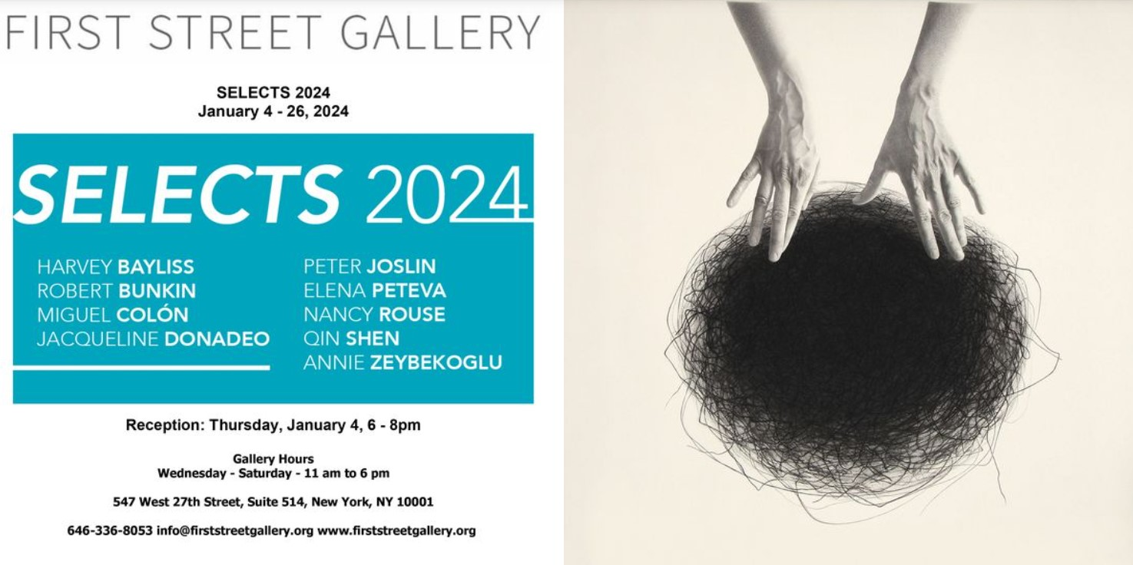

- January 11th, 8 pm: An evening of Kazandjiev, Poturlyan, Piazzolla and Brahms at Carnegie Hall. Performers incl. Borislava Iltcheva and Alexander Ilchev. Book here. Address: Weill Recital Hall, West 57th Street, New York. Language: English.


- January 17th, 6:30 pm: Schubertiada, organized by Bulgarian Concert Evenings in New York. Performers: Mariana Karpatova, mezzo-soprano, Randall Scarlata, baritone, Georgy Valtchev, violin, Caitlin Sullivan, cello, Lora Tchekoratova, piano. Book at https://www.bceny.org/season-2023-24. Address: Consulate General of Bulgaria in New York, 121 E 62nd St, New York. Language: English.
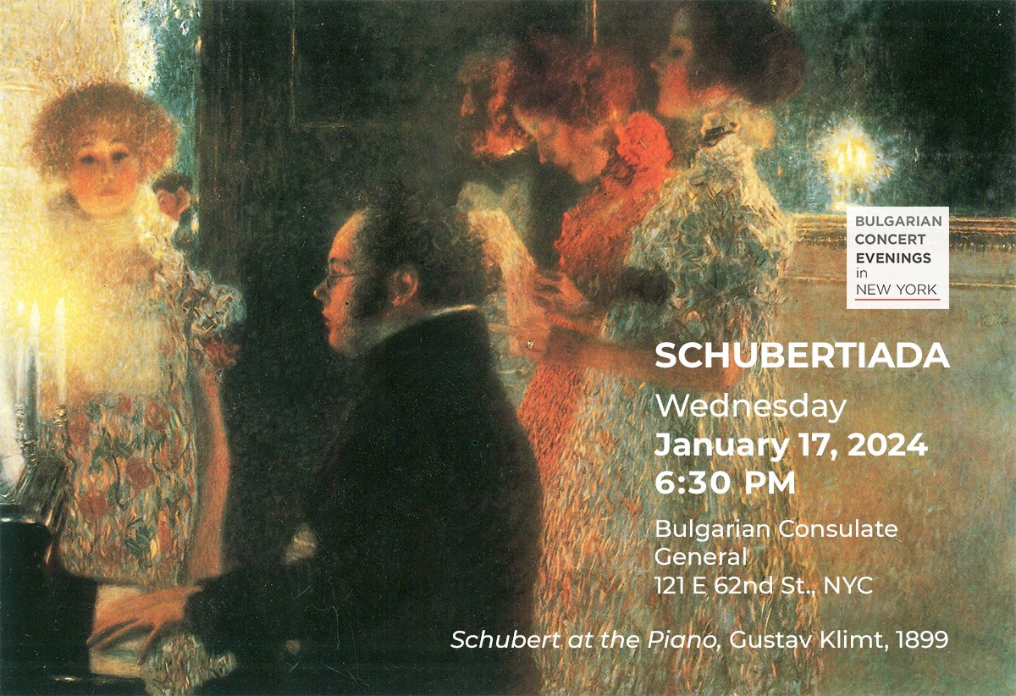

- January 29th, 6 pm: Angelа Rodel, a literary translator, awarded with the 2023 International Booker Prize, will present the first English-language translation of a twentieth-century Bulgarian classic, Vera Mutafchieva's sprawling novel of Ottoman court intrigue, emigration, and loss. In conversation with Edwin Frank, editorial director of the NYRB Classics series. The event will take place at Rizzoli Bookstore, 1133 Broadway New York, NY 10010. Language: English. Register here:
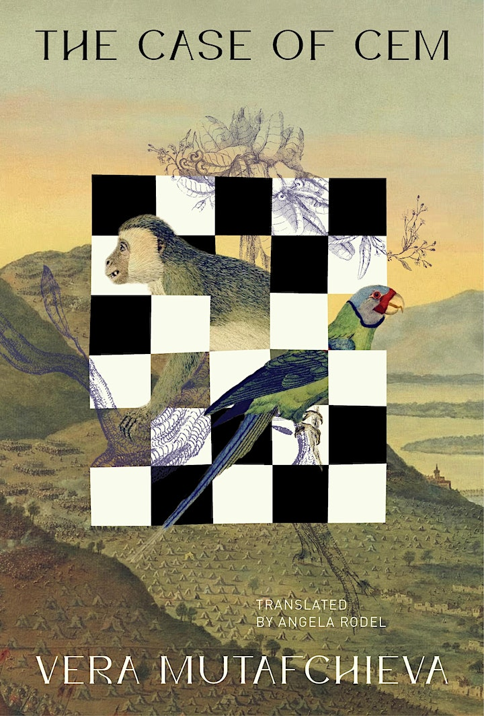

- January 30th, 4.30 pm: Angelа Rodel, a literary translator, awarded with the 2023 International Booker Prize, will participate in a literary event on: “Cem Sultan and the Discreet Monsters of the Past: Translation Strategies for History in Bulgarian Fiction”. She will explore the unorthodox approaches to history and the challenges such framing of the past creates for translation in her most recent works. The event will take place at Yale University, Humanities Quadrangle (HQ), Alice Cinema (L01). Language: English.
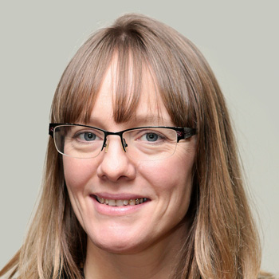

• January 31st, 6 pm: Angelа Rodel, a literary translator, awarded with the 2023 International Booker Prize, will discuss and celebrate the release of the Bulgarian classic The Case of Cem by Vera Mutafchieva. She will be in conversation with writer Claire Messud. The event will take place at 279 Harvard Street, Coolidge Corner, Brookline, MA 02446-2908. Language: English. Register here.
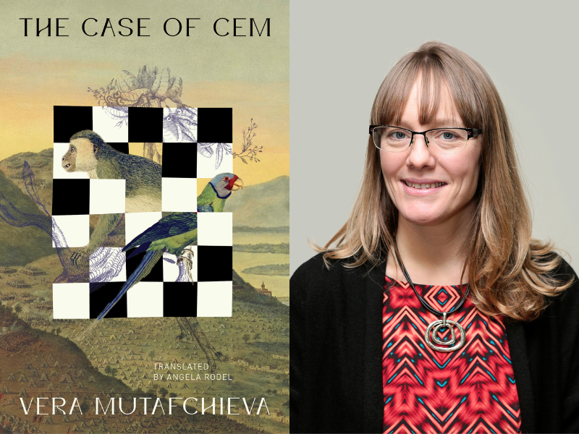

Information about the activities of the Consulate General is regularly posted through our social media accounts:
Генерално Консулство Ню Йорк | Facebook
Consulate General of Bulgaria in New York | New York NY | Facebook
Consulate General of Bulgaria in New York 🇧🇬🗽 (@ConsulateBGinNY) / Twitter
For appointments: calendly.com/consulate_newyork

Consulate General of the Republic of Bulgaria
121 East 62nd St., New York, NY 10065
Tel. 212 935 4646
https://www.mfa.bg/embassies/usagc

